
Date | 30 September 2026
Team ID | SWTID-2026-9152
Project Name | Import Data using Transform Maps (Spreadsheet)
Team Leader | Muthupramu M
Team Member | Sankaralashmi A
 | Regina S
 | Thansiya A
Maximum Marks | 5 Marks

Project Title:
Import Data using Transform Maps

6. Project Testing Phase

The testing phase focused on ensuring data integrity, specifically validating the 'Coalesce' functionality.

- Test Case 1 (Initial Import): Verified that all rows from the source file were successfully inserted into the Employee Test table without errors.
- Test Case 2 (Update/Coalesce Test): The Coalesce field was set to true for Employee ID. The source Excel file was modified (changing an email ID and a name) and new rows were added.
- Test Result: Upon re-running the transform, the Transform History confirmed that existing records were correctly 'Updated' (not duplicated) and the new rows were 'Inserted'. The data in the target table accurately reflected these changes, proving the system's ability to prevent duplicates.

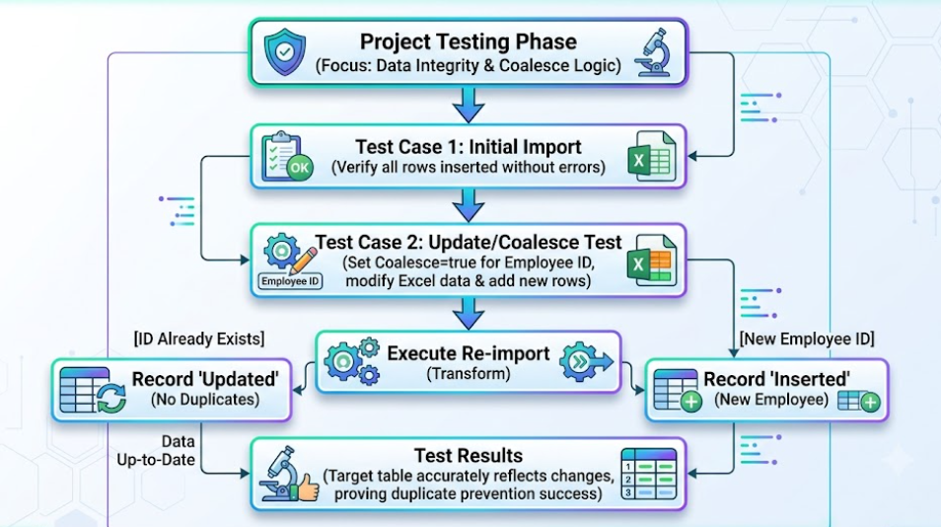

Screenshot:

